DIGITAL DESIGN

CS223

Section: 001

Lab3 Report

Name: Tolga Han Arslan

ID: 22003061

Date: 28.11.2022

a) Your improved Moore machine state transition diagram, state encodings, state transition table, output table, next state, and output equations.

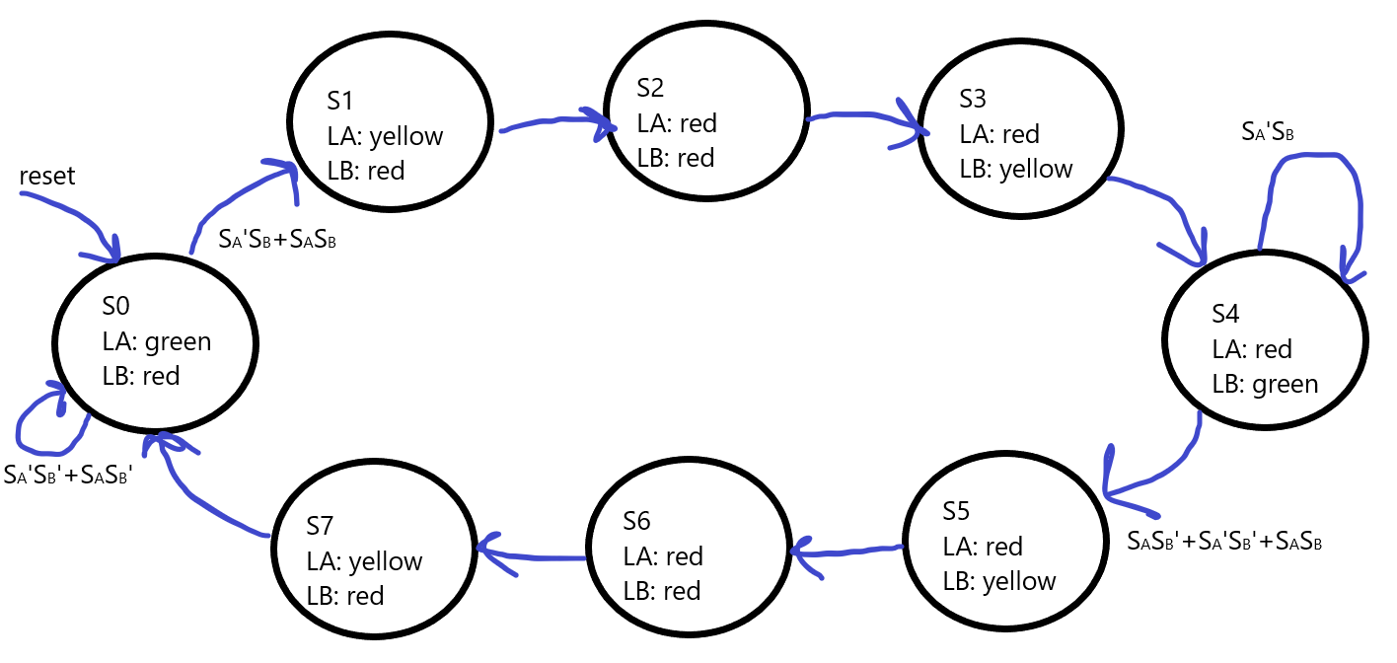

State and Output Encodings:

|  |  |
| --- | --- |
| State | Encoding S2:0 |
| S0 | 000 |
| S1 | 001 |
| S2 | 010 |
| S3 | 011 |
| S4 | 100 |
| S5 | 101 |
| S6 | 110 |
| S7 | 111 |

|  |  |
| --- | --- |
| Output | Encoding L2:0 |
| Red | 111 |
| Green | 011 |
| Yellow | 001 |

State Transition Table:

|  |  |  |  |  |  |  |  |
| --- | --- | --- | --- | --- | --- | --- | --- |
| Current State | | | Inputs | | Next State | | |
| S2 | S1 | S0 | SA | SB | S2’ | S1’ | S0’ |
| 0 | 0 | 0 | X | 0 | 0 | 0 | 0 |
| 0 | 0 | 0 | X | 1 | 0 | 0 | 1 |
| 0 | 0 | 1 | X | X | 0 | 1 | 0 |
| 0 | 1 | 0 | X | X | 0 | 1 | 1 |
| 0 | 1 | 1 | X | X | 1 | 0 | 0 |
| 1 | 0 | 0 | 0 | 1 | 1 | 0 | 0 |
| 1 | 0 | 0 | X | 0 | 1 | 0 | 1 |
| 1 | 0 | 0 | 1 | 1 | 1 | 0 | 1 |
| 1 | 0 | 1 | X | X | 1 | 1 | 0 |
| 1 | 1 | 0 | X | X | 1 | 1 | 1 |
| 1 | 1 | 1 | X | X | 0 | 0 | 0 |

Output table:

|  |  |  |  |  |  |  |  |  |
| --- | --- | --- | --- | --- | --- | --- | --- | --- |
| Current State | | | Output | | | | | |
| S2 | S1 | S0 | LA2 | LA1 | LA0 | LB2 | LB1 | LB0 |
| 0 | 0 | 0 | 0 | 1 | 1 | 1 | 1 | 1 |
| 0 | 0 | 1 | 0 | 0 | 1 | 1 | 1 | 1 |
| 0 | 1 | 0 | 1 | 1 | 1 | 1 | 1 | 1 |
| 0 | 1 | 1 | 1 | 1 | 1 | 0 | 1 | 1 |
| 1 | 0 | 0 | 1 | 1 | 1 | 0 | 1 | 1 |
| 1 | 0 | 1 | 1 | 1 | 1 | 0 | 0 | 1 |
| 1 | 1 | 0 | 1 | 1 | 1 | 1 | 1 | 1 |
| 1 | 1 | 1 | 0 | 0 | 1 | 1 | 1 | 1 |

Next State: (On the right hand side “ ’ ” means not)

$S_{2}^{'}=S_{2}S_{1}^{'}+ S_{2}^{'}S_{1}S_{0}+ S_{2}S_{1}S_{0}^{'}$

$$S_{1}^{'}= S_{1}⊕S_{0}$$

$$S_{0}^{'}= S_{1}S_{0}^{'}+ S_{1}^{'}S_{0}^{'}(S_{2}⊕S_{B}+\left(S_{2}S_{A}S_{B}\right))$$

Output:

$$L_{A0}=1$$

$$L_{A1}=\left(S_{2}⊕S_{1}\right)+S_{2}S_{1}S_{0 }^{'}+ S_{2}^{'}S_{1}^{'}S_{0}^{'}$$

$$L_{A2}=\left(S_{2}⊕S_{1}\right)+S_{2}S_{1}S_{0}^{'}$$

$$L_{B0}=1$$

$$L_{B1}=S_{2}^{'}S_{1}^{'}+S_{2}^{'}S_{1}S_{0}^{'}+S_{2}S_{1}^{'}S_{0}^{'}+S_{2}S_{1}$$

$$L_{B2}=S_{2}^{'}S_{1}^{'}+S_{2}^{'}S_{1}S_{0}^{'}+S_{2}S_{1}$$

b) Your Finite State Machine schematic.

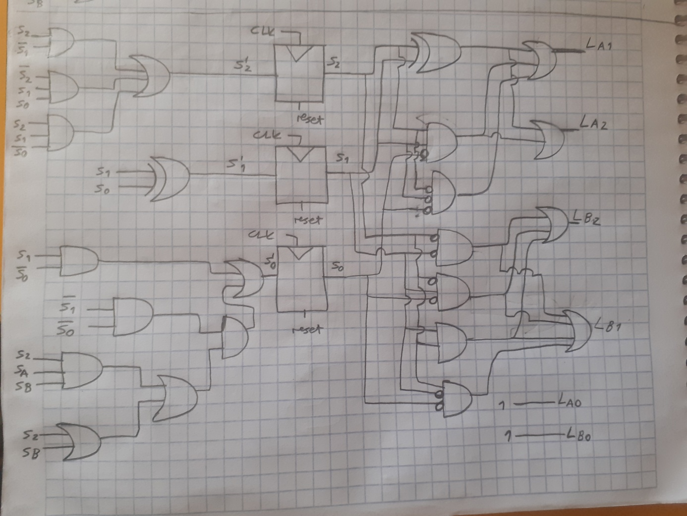

c) How many flip-flops do you need to implement this problem?

3 flip-flops

d) Redesign of your outputs using decoders.

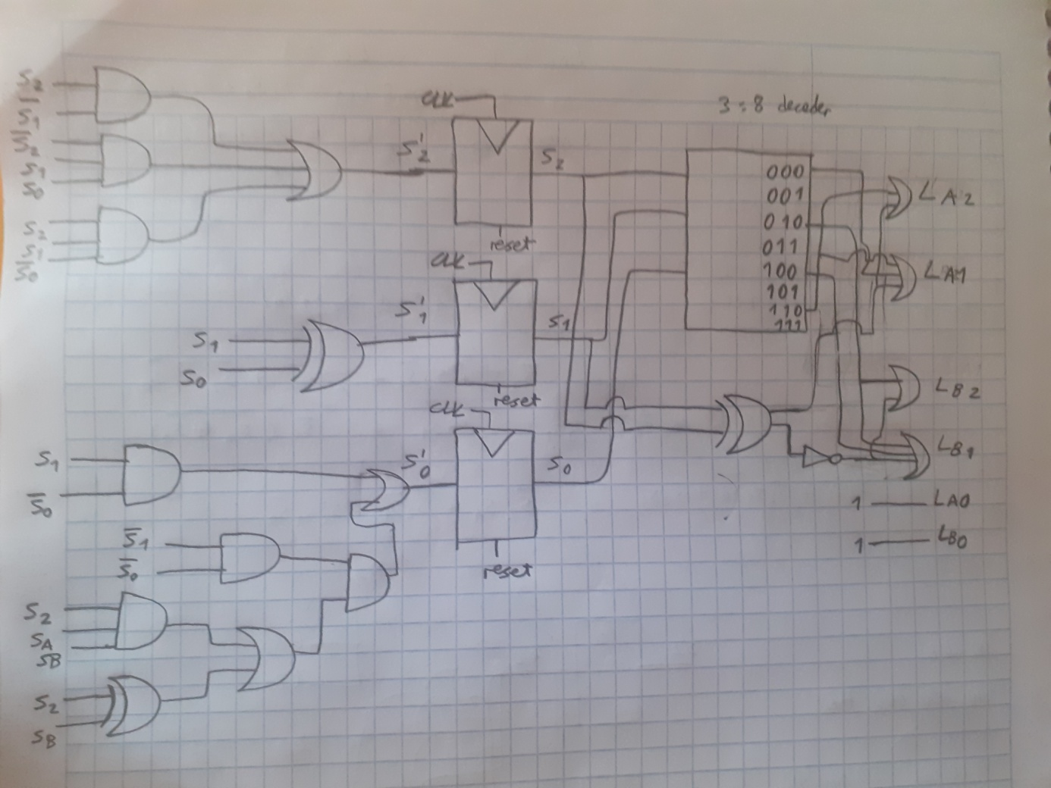

e) Your System Verilog design code and testbench.

module fsm(

input logic clk,

input logic reset,

input logic SA, SB,

output logic [2:0] LA, [2:0] LB

);

typedef enum logic [2:0]{S0,S1,S2,S3,S4,S5,S6,S7} statetype;

statetype state, nextstate; // dont put [2:0] here

//state register

always_ff @(posedge clk, posedge reset)

if(reset) state <= S0;

else state <= nextstate;

//next state logic

always_comb

case(state)

S0: if(~SA&SB|SA&SB) nextstate = S1;

else nextstate = S0;

S1: nextstate = S2;

S2: nextstate = S3;

S3: nextstate = S4;

S4: if(~SA&SB) nextstate = S4;

else nextstate = S5;

S5: nextstate = S6;

S6: nextstate = S7;

S7: nextstate = S0;

endcase

assign LA[0] = 1;

assign LA[1] = (state[2]^state[1]) | (state[2]&state[1]&~state[0]) | (~state[2]&~state[1]&~state[0]);

assign LA[2] = (state[2]^state[1]) | (state[2]&state[1]&~state[0]);

assign LB[0] = 1;

assign LB[1] = (~state[2]&~state[1]) | (~state[2]&state[1]&~state[0]) | (state[2]&~state[1]&~state[0]) | (state[2]&state[1]);

assign LB[2] = (~state[2]&~state[1]) | (~state[2]&state[1]&~state[0]) | (state[2]&state[1]);

endmodule

module fsm_tb();

logic clk, reset, SA, SB;

logic [2:0] LA, LB;

fsm dut(clk, reset, SA, SB, LA,LB);

initial

begin

reset <= 1; #100;

reset <= 0;

SA = 0; SB = 0; #100;

SA = 0; SB = 1; #100;

SA = 0; SB = 0; #100;

SA = 1; SB = 0; #100;

SA = 0; SB = 0; #100;

SA = 1; SB = 1; #100;

reset <=1;

SA = 0; SB = 0; #100;

SA = 0; SB = 1; #100;

SA = 0; SB = 0; #100;

SA = 1; SB = 0; #100;

SA = 0; SB = 0; #100;

SA = 1; SB = 1; #100;

end

always

begin

clk<=1; #10;

clk<=0; #10;

end

endmodule